

DEPARTMENT of COMPUTER SCIENCE & ENGINEERING SOUTHEAST UNIVERSITY

**Internship Report on**

**Web Development and Web Design**

*A dissertation submitted to the Southeast University in partial fulfillment of the requirements for the degree of B. Sc. in Computer Science & Engineering*

Submitted by

Nafija Anjum Dithi Barai

ID: 2016100000073 ID: 2016100000066 Batch: 43rd Batch: 43rd

Supervised by

Monirul Hasan

Lecturer, Department of CSE

Southeast University

Copyright © Year 2020

June, 2020

# **Letter of Transmittal**

June 22, 2020

The chairman

Department of Computer Science & Engineering

Southeast University

Banani, Dhaka

Through: Supervisor, Monirul Hasan

Subject: Submission of Internship Report.

Dear Sir,

With immense gratitude, we are submitting here our internship report on “Web development and Web design ”. It was our most valuable experience to work with MadenetIT. The internship work has been accomplished by following the instruction of yours and filling the requirement of the Southeast University.

This internship report attempts to describe our observation and learning during the study of this course. With our utmost earnestness and sincere effort we have tried to make this internship report widespread and informative as much as possible.

We sincerely hope that this report meets your approval and demonstrate our ability to complete our graduation

Thank You.

Sincerely yours,

Nafija Anjum Supervisor :

Id: 2016100000073 Monirul Hasan

Batch: 43rd Lecturer ,

Program: CSE Department of CSE

Southeast University

Dithi Barai

Id : 2016100000066

Batch: 43rd

Program:43

# **Letter of Endorsement**

This is to certify that the internship report titled “Web Development and Web Des ” has been submitted by Nafija Anjum and Dithi Barai in the partial fulfillment of the requirements for award the degree (B.Sc. in CSE) in department of Computer of Science & Engineering of Southeast University. This is a record analysis carried out by Nafija Anjum, ID: 2016100000073 and Dithi Barai, ID : 2016100000066, under my supervision. No part of the internship report has been submitted for any other degree and the performance of the student has been accepted as satisfactory.

**Approved by the Co-Supervisor Approved by the Supervisor**

Zunayed Ahmed Monirul Hasan

Project Manager Lecturer

MadenetIT Department of CSE

Southeast University

# Abstract:

The Real Estate Web Application is an interactive, effective, and revenue-generating website designed for the Real Estate Industry. The main objective of this application is to help the Real Estate Company to display an unlimited number of property listings on the website.

The primary focus is the integration of a CRM lead management system with a highly interactive IDX search service. The goal is to keep buyers on the website and to capture them as leads by giving them simply the best home search service. This system not only provides an easy and convenient way to search for listings but also displays the entire list of properties in a customized grid format. Along with this target was to build a CRM to keep in touch with past clients, nurture leads. As interns, our job was to develop the automated system to keep track of customer interactions which will eventually be converted into leads.

The Real estate IDX website is built in WordPress platform and whole design controlled by WordPress plugins. Our experience over there was tremendous and we have got a chance to perceive real-life interactions with clients. Most of the part of our report is based on practical knowledge and what we have done there during our internship period.

# **Acknowledgements**

At first, Thanks to Almighty Allah.

We would like to show our gratitude to our honorable supervisor Monirul Hasan, Lecturer, Department of Computer Science and Engineering for giving us the idea for making the report and guiding us with patience as well as encouraging us with a lot of support to remove the confusions. We are especially thankful to our co-supervisor and MadenetIT for their kind cooperation and helping role. It was a great chance for us to learn and helps us to develop our professional skills. Especially, thankful to our co-supervisor Zunayed Ahmed who has helped us enormously to completed our internship. We would like to thank everyone who has provided feedback and suggestion on our work and on our internship report.

Contents

Letter of Transmittal……………………………………………………………………………..………………………………….1

Letter of Endorsement …………………………………………………………………….……………………………………….2

Abstract…………………………………………………………………………………………………………………………………….3

Acknowledgements………………………………………………………………………..………………………………………...4

Chapter 1

1.1 Why need an internship…………………………………………………………………………………………..……......7

1.2 Report Origin ………………………………………………………………………………………………………………........7

1.3 Purpose of the Study…………………………………………………………………………………………………………..7

1.4 Limitations of the Study…………………………………………………………………………………………………..….8 1.5 Scope & Methodology………………………………………………………………………………………………...........8

Chapter 2

2.1 About MadenetIT………………………………………………………………………………………………………….……9

2.2 Mission…………………………………………………………………………………………………………………………..…..9

2.3 Vision ……………………………………………………………………………………………………………………………......9

2.4 Company Services…………………………………………………………………………………………………………..…10

2.5 Human Resource …………………………………………………………………………………………………………..….10

2.6 Industry Experience ……………………………………………………………………………………………………..…..11

2.7 Our Work Activities …………………………………………………………………………………………..………..…….11

Chapter 3

3.1 WordPress Installation & Set up ……………………………………………………………….………………………12

3.2 Website Tweaks in design………………………………………………………………………………………………….14

3.3 WordPress Plugin Customization……………………………………………………………………………………….19

3.4 Website Content Customization………………………………………………………………………………………..22

3.5 IDX integration for propety listing, search option, and map ……………………………………..………24 3.6 CRM integration for IDX provider………………………………………………………………………………………27

# Chapter 4

4.1 Learned from the Institute………………………………………………………………………………………………..44

4.2 Implication to University’s Internship Program…………..…………………………………………………….45 4.3 Effects on Personal Skills…………………………………………………………………………………………………..45

Chapter 5

Limitations …………………………………………………………………………………………………………………………..46

Chapter 6

Conclusion …………………………………………………………………………………………………………………………..47

Chapter 7

References……………………………………………………………………………………………………………………………48

List of figures

Figure 4.1: HomePage ……………………………………………………………………………..…………………………………………..

Figure 4.2 : Featured Property ……………………………………………………………………………..………………………………….

Figure 4.3 : Communities……………………………………………………………………………..………………………………….

Figure 4.4 : About Page ……………………………………………………………………………..………………………………….

Figure 4.5 : Contact Page ……………………………………………………………………………..………………………………….

Figure 4.6 : Home Page……………………………………………………………………………..………………………………….

Figure 4.7 : About Page ……………………………………………………………………………..………………………………….

Figure 4.8 :Buy Page ……………………………………………………………………………..………………………………….

Figure 4.9 : Neighborhood ……………………………………………………………………………..………………………………….

Figure 4.10 Contact Page ……………………………………………………………………………..………………………………….

Figure 4.11 : HomePage ……………………………………………………………………………..………………………………….

Figure 4.12 : Advanced Search ……………………………………………………………………………..………………………………….

Figure 4.13 :MapSearch ……………………………………………………………………………..………………………………….

Figure 4.14 : Blog Page ……………………………………………………………………………..………………………………….

Figure 4.15 :FAQ ……………………………………………………………………………..………………………………….

Figure 4.16: ContactPage ……………………………………………………………………………..………………………………….

Chapter 1 Introduction

# 1.1 Why need an Internship?

Most of the undergraduate students do not have any real-life experience of any kind of professional experience. An internship is a great opportunity to gain some firsthand experience of the professional environment for a student who will be graduated soon. It tests a student’s knowledge gained through the years in the academy and applies that knowledge in a practical environment, observes and learns from people who have been working in the industry for a few years, and working in a demanding, pressurized, and fast environment of the IT industry. The three-month internship program is another, possibly maximum effective, a manner of achieving industry orientation. An internship facilitates the students to link- up their educational enjoyment with industry practices. We hope we are successful, the future of our lifestyles will prove the fact of success and failure. The organization we were sent for an internship is MadenetIT.

# 1.2 Report Origin:

As a mandatory requirement of the B.Sc. in Computer Science and Engineering (CSE) program under the School of Science at Southeast University this report entitled “Web Developer and Web Design” – is a connived depiction of the three months long internship program. We have got deep knowledge of web design, development, and maintenance during our internship period at MadenetIT.

# 1.3 Purpose of the Study:

The purpose of this report cognates the internship purpose. The internship objective was to gather knowledge and experiencing the corporate working with the experts who are leading in the IT firm. In this regard, this report is contemplating the knowledge and experience accumulated from the internship program. With the set guidance and proposal by the Department of Computer Science, Southeast University and with the kind advice of both organization and internship Supervisor this report comprises of an organization part and our earned working experience.

# 1.4 Limitations of the Study:

This report is “Real Estate Web Application” but there is some lack of information due to some limitations. To appraise an organization like MadenetIT, three months’ time is very short. Though initially, we worked at the office premise due to pandemics we have to work from home and it was very difficult for us to communicate with the project manager to give briefs. We could not avail to collect all our required data. With all these limitations We tried our best to make this report authentic and worth reading.

# 1.5 Scope and Methodology:

This report gives an insight into the experience that we faced in our workplace at MadenetIT. As well as it also provides a brief description of MadenetIT Ltd.

Our internship was to work on Real estate e-commerce websites. These websites enable buyers to search for property listings online. The motive of developing this application is to design a featurerich search engine that can make the search for commercial land/properties an easy task. There we integrated a CRM system to automate the interactions of the clients through these websites. Along with this we also work on Marketing and SEO. We previously did not work on marketing, so this also helped us to gain some knowledge about digital marketing which is very essential for website traffics. Overall this internship gives us immense experience and a feel of professionals.

# Chapter 2

**Profile of MadenetIT**

# 2.1 About MadenetIT

**MadentIT** is one of the most robust and leading Domain and Host- ing selling, Professional Skill Development and Support Solutions Company in Bangladesh. Since its inception in 2011, the company is working with a mission to meet the consumer needs and aspiration in distributing highquality software and Domain and hosting selling hardware products and services through maintaining the high level of customer satisfaction. **MadenetIT.** has started its journey as a proprietorship company in 2011. It was a very robust and quickly growing company in Bangladesh. With good reputation and full furnished prod- uct its form as a company as the name of **MadenetIT** in 2011.

# 2.2 Mission

**Madenet IT** is a modern and Digital agency for advertising and marketing. A one step solution for your business to create a powerful online presence

A production house for Branding, Advertising, Educating and marketing for businesses. We are rendering sales for businesses.

**Madenet IT** is forming with Specialists Team in different sections and making a cool partnership with clients for render leads and sales.

We offer Optimized ads and marketing strategy for your product to reach at right Audiences.

# 2.3 Vision

We develop our client online presence and Create a automatic advertising startegy for grow their business. Our passionate segment is Real estate business and Business coaches. We develop website to present their services and Run ads on Facebook and Google. Our technical team have blast experience in CRM technology to maintain high level customer relatioship with client's customers.

# 2.4 Company Services

**Branding Design**

Branding strategy design is first plan to make your small business successful.

**Web Development**

Customers consider your website as an online offiec address for your service.

**Content Stategy**

We develop engage able content strategy depend on your business model.

**Generating sales**

In order to get Sales we will make a best campaign for your online marketing in Facebook and Google .

# 2.5 Human Resource

**MadenetIT** has 18 employees at this moment and they are planning to recruit more. Since the beginning, MadenetIT has grown in the number of resources and production every year.

**MadenetIT** don’t hire developers, designers or QA engineers, it hires people who solve problems. And it hires only the best. **MadenetIT** runs regular training and review sessions to keep it on the top.

# 2.6 Industry Experience

**MadenetIT** has been building software for various industries since **2011**. It has worked with many technology platforms and has collaborated with many teams over these years. The industries **MadenetIT** has been involved with are:

1. Domain and Hosting Selling
2. Mobile payment business(B2B)
3. SMS selling
4. Cloud server rent
5. Client Relationship Management System

# 2.7 Our work activities

As Internees, we have been put into the web developer section to provide service to office employees and clients. During the internship, our responsibility was handling CRM automated system. We worked for three months ( February –May). Every day we have to update our work and report our co-supervisor.

Chapter 3

**Details of Internship Work**

## Our Project Involvement

We assist our project manager to design the online real estate website with a highly interactive IDX system through which a user can access information and manage all the adding, updating, deleting the assets, and some of its tasks. To automate the interaction of the client we also integrate the CRM which builds stronger client relationship.

### 3.1 WordPress Installtion and Setup

#### Step 1: Download WordPress

Download the WordPress package to local computer from [wordpress.org.](https://wordpress.org/download/)Unzip the downloaded file to a folder on local computer.

#### Step 2: Upload WordPress to Hosting Account

There are three available options for uploading WordPress to hosting account. When unzipped the file in Step 1, there will be a folder named wordpress, and the contents need to be uploaded to hosting account's file manager. This can be accomplished this one of three ways:

Upload via FTP

Upload via File Manager

Upload via SSH

#### Step 3: Create MySQL Database and User

WordPress stores its information in a database. Therefore, a database will need to be created.

Log into cPanel.

In the Databases section, click the MySQL Database Wizard icon.

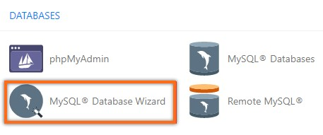

For Step 1: Create A Database, enter the database name, and click Next Step.

For Step 2: Create Database Users, enter the database user name and password, and click Create User.

For Step 3: Add User to the Database, click the All Privileges checkbox and click Next Step. For Step 4: Complete the task, make a note of the database name, username, and password, as you will need them for [Step 4](https://www.hostgator.com/help/article/how-to-install-wordpress-manually#4) below.

#### Step 4: Configure wp-config.php

**The wp-config-**sample.php file contains the database information and tells the WordPress application from which database to pull data. This step must be completed to ensure the correct database information is associated with the WordPress installation.

**The wp-**config-sample.php file can be found in File Manager in the folder where WordPress is installed. The folder for your primary domain is public_html by default, so the steps below show the process for that folder.

1. Log in to cPanel.
2. In the Files section, click the File Manager icon.
3. From the left-hand navigation menu in File Manager, click public_html to open the folder in the right-hand panel.
4. Click on the Settings button found on the top right-hand corner of your File Manager to show a pop-up box on the screen.
5. In the pop-up box, check the box for Show Hidden Files (dotfiles), then click Save.
6. In the right-hand panel of the File Manager, locate the wp-config-sample.php file.
7. Right-click on the file, select Rename, change the name of the file to wp-config.php, and then click the Rename File button to save the change.
8. Right-click on the wp-config.php file and select Edit.
9. A second pop-up box will appear, click the Edit button to continue to the file.
10. When the file opens, look for the following information:
11. Replace database_name_here with the name of the database you created
12. Replace username_here with the username of the database you created.
13. Replace password_here with the password of the database that you created.

11. When done editing, click the Save Changes button on the top right, and then Close to close the file and return to the File Manager.

#### Step 5: Run the Installation

Open a new browser window and enter domain to run the installation script. Depending on where installed the script, this will be automatically redirected to either of the following URLs: If uploaded WordPress to the domain's root folder, this should be redirected to:

https://example.com/wp-admin/install.php

If uploaded WordPress to a subfolder of domain's directory, then the URL will be this format:

https://example.com/yoursubfolder/wp-admin/install.php

#### Step 6: Complete the Installation

Once correct WordPress URL in a browser is accessed, WordPress setup page prompting to select your preferred language. Select preferred language and click the Continue button.

Click the Install WordPress button, and It should take to the final screen, which says, "WordPress has been installed. Thank you, and enjoy!". It will display the username chosen on the previous page and a placeholder for password. Click the Log In button to log in to the WordPress Admin Dashboard to begin building your site

# 3.2 Website Tweaks in design

Many small elements come together on a website to create a memorable experience for a visitor. These elements add little in view but have a large impact on the user and your conversation rates. By fixing tiny little website issues, we see a drastic improvement to the website’s performance by making it more engaging for the visitors. The ease of features that are offered to a user, increase the time he stays on your website thus making it more probable for him to make a purchase or get in touch with you for a service.

We offer a variety of minor tweaks to your website that are guaranteed to attract a lot new visitors and advance your web repo.

1. **Image Slider**: Uplift the design and add a spark to the present website with an interesting image slider. Image sliders allow increased interaction with the users in the form of crisp call to actions and also pave way for users to traverse the entire website.

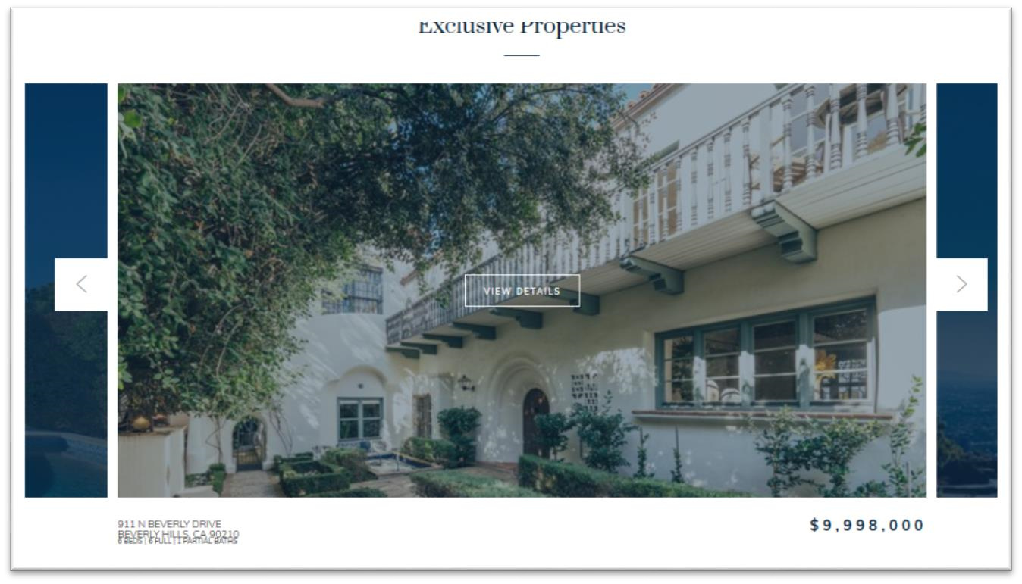

1. **Gallery:** A simple or masonry gallery of your products, events, office premises, etc not only makes a website more interesting but also adds full marks to your credibility. These images can further be sorted on any parameter in real time.

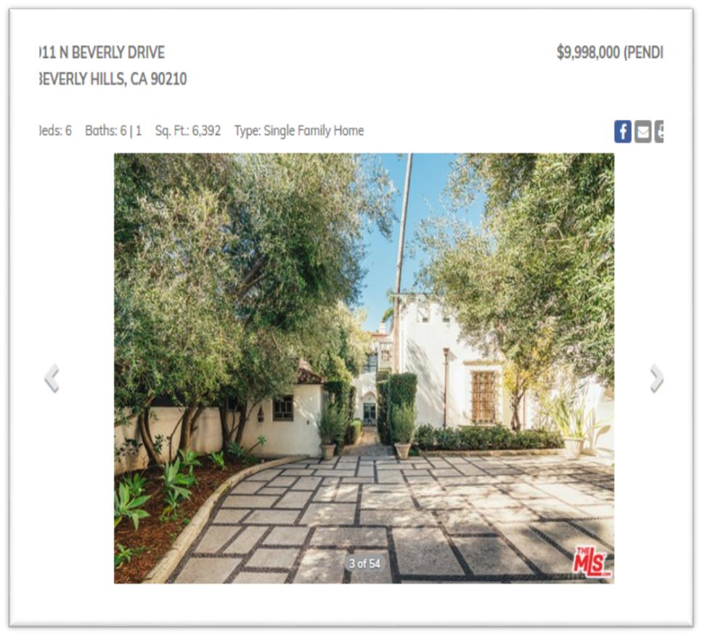

1. **Image Background Parallax:** Most modernistic websites have an image parallax with an image in the background and corresponding text in the foreground. These background images scroll slowly with respect to the text and create a beautiful sight being the highlight of a website.

1. **Social media integration:** People who visit our website and like it have high probabilities of connecting with us on social media to stay informed about offers and new product launches. Enhance our website by linking it to our social media profiles which will also lead to an increase in likes and follows.



1. **Google Maps Integration:** Encourage users to visit you at your office for discussions over coffee or increase footfall to your physical shop. Google map facilitates the websites users to get road directions to your location by the click of the button.

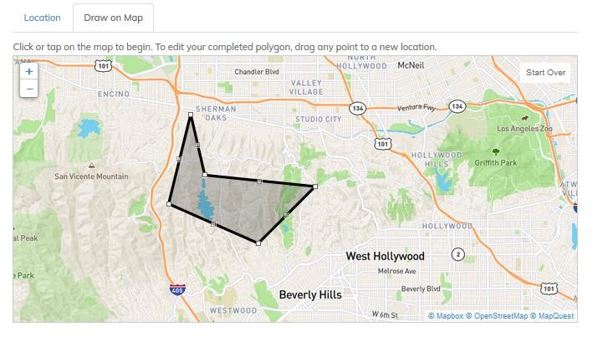

1. **Google Search:** Enhance your website with the most authentic Google search. Enable users to search products or pieces of text from all pages on your website including blogs. Simple to use, on-website search from Google.

1. **Google Analytics:**This allows you to keep track of your visitors, their geographical location and likings on your website. Monthly web data can be analyzed to increase conversion rates on your website – the most beneficial service.

1. **Wordpress Blog**: Google loves updated website and a blog can improve your page ranks in no time. A blog is the easiest way to share information with your audience and offer them to write their views in comments. Avail this service to see your viewers spending more time on your website.

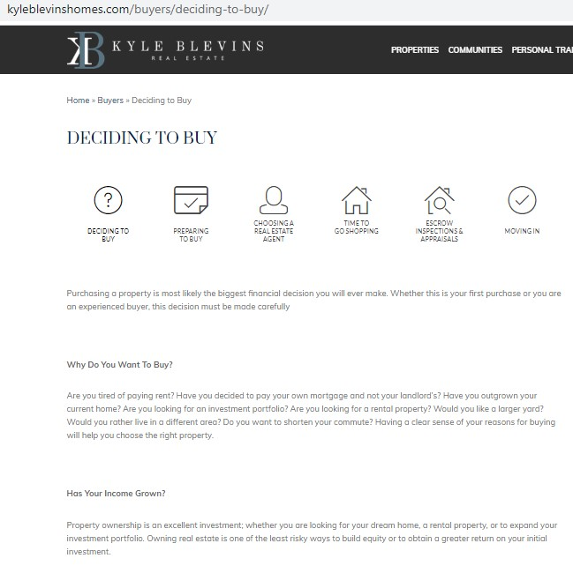

1. **Sliding Testimonials:** Allow new visitors to read good about your past work from you clientele. Sliding testimonials showcased with client image or business logo are known to increase your credibility and improve lead generation on your website.

1. **Responsive Web Design:** Offer an excellent experience to visitors who browse your website on the go – allow them to visit your website without having to zoom in to read it’s content and see graphics. Increase conversion rates by 65%.

1. **Style Guide:** CSS files control the look and feel of a website; our expert front end designers are capable of changing the colors, fonts and other major designing elements without changing any piece of HTML code in your website. Give a major revamp to your website and making it instantly attractive.

# 3.3 WordPress Plugin Customization

WordPress Plugins allows you to easily modify, customize, and enhance a WordPress site. Instead of changing the core program code of WordPress, you can add functionality with WordPress Plugins

Following are the simple steps to Customize Plugins in WordPress.

#### Step (1) − Click on Plugins → Add New

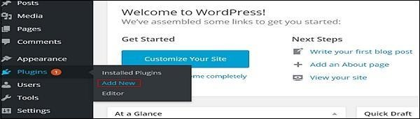

#### Step (2) − Install and activate the Custom Login Page Customizer Plugin

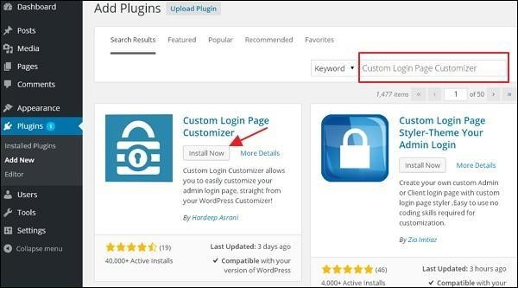

**Step (3)** − Click on **Appearance → Login Customize** section.

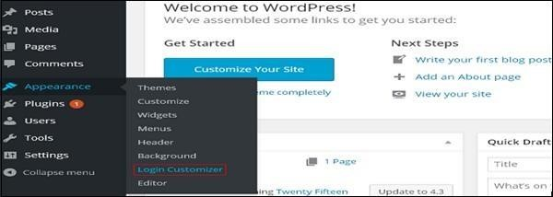

**Step (4)** − Click on **Start Customizing** button to proceed further.

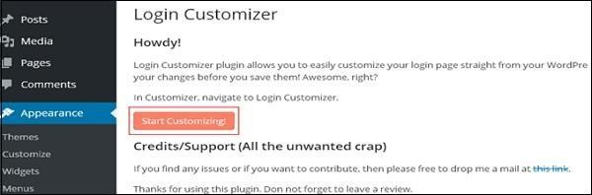

**Step (5)** − It will launch the built-in WordPress theme **customizer**. You can customize the theme and make it look the way you want.

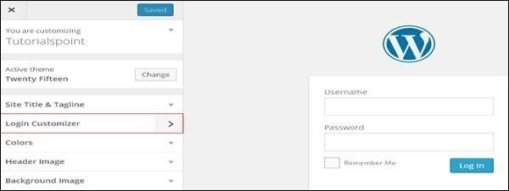

**Step (6)** − The customized login page will appear as shown in the following screen.

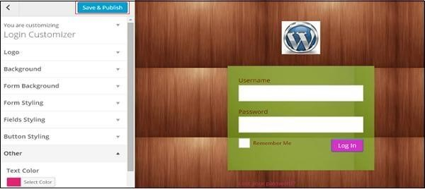

* **Logo** − Upload logo of your choice to replace the default WordPress logo.
* **Background** − Add background image or you can choose a background color of your choice.
* **Form Background** − Select form background image or color for login form container of your choice.

Most of the selections in the customizer panel are transparent. You can check all the selections in the customizer to adjust the setting as per your requirement of your login page. Click on **Save and Publish** button.

# 3.4 Website Content Customization

Customization lets users make their own selections about what they want to see, or set preferences for how information is organized or displayed. It can enhance user experience because it allows users to control their interaction.

#### Headlines and heros

For most site visitors, the homepage and other key landing pages are the first touch point they interact with. The headline here is the best opportunity to speak directly to high-value leads as early in the lead journey as possible.



A visitor from a real estate company would [see a personalized headline](https://clearbit.com/customers/tealium) that said: "Helping people make healthy moves."

#### Product or plan features

Highlighted a specific features, on key pages based on our audience's firmographic attributes or referral context.

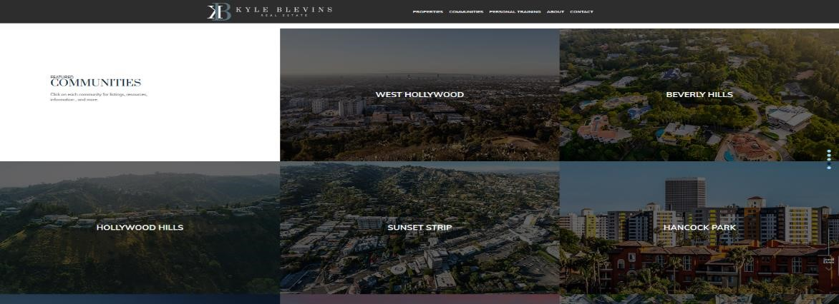

#### Email updates

Users could indicate favorite properties and receive email updates when those properties were available on the site.

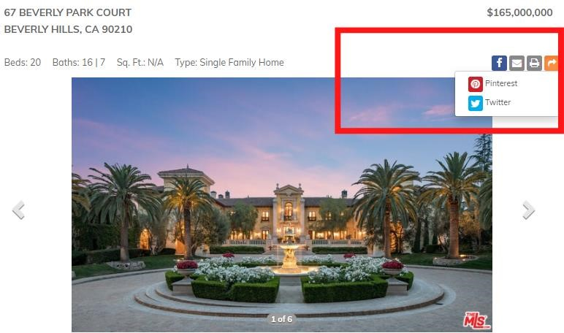

#### Featured blog posts (and other content)

Blog posts are useful for engagement along the path to conversion.Recommend blog post and resources, especially how-to's, customer success stories, and other product-related or educational pieces based on role.

Suggest blog posts that consider previous behavior, such as downloading an ebook or reading about a certain product.



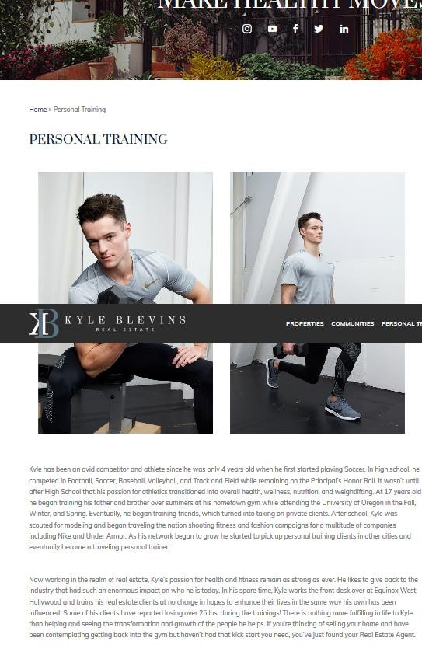

### 3.5 IDX Integration For WordPress

IDX is what enables members of a multiple listing service(MLS) to integrate real estate listings from the MLS database into their own websites. IDX eastablishes a data connection between website and the MLS, import listings, and displays them on website.

#### 3.5.1 Property Listing

The listings are updated every few hours, so our audience always has access to the most recent listings and can contact us for information about the available properties.

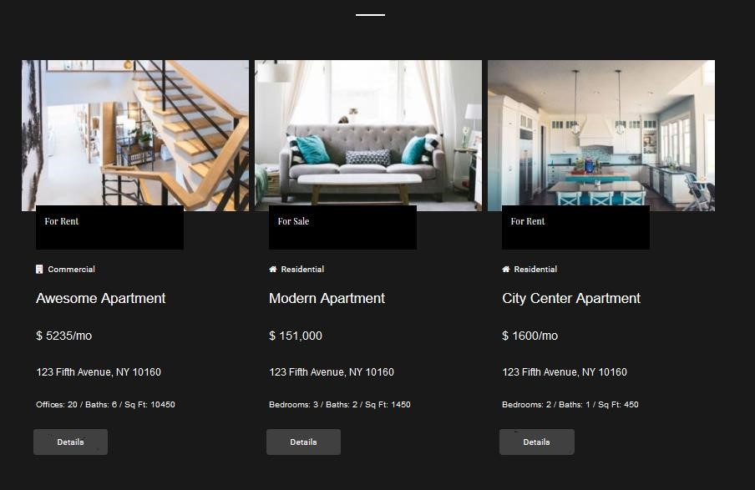

#### 3.5.2 Search Options

The most significant feature in these websites is the interactive search criterion which lets the buyer specify their requirements to get the correct set of records from the database. The search tool should be strong enough to include all the required features which a buyer may desire.

## **Basic Search Bar**

Buyers can search via giving the basic information of their desired property type and can have the filtered properties listing.

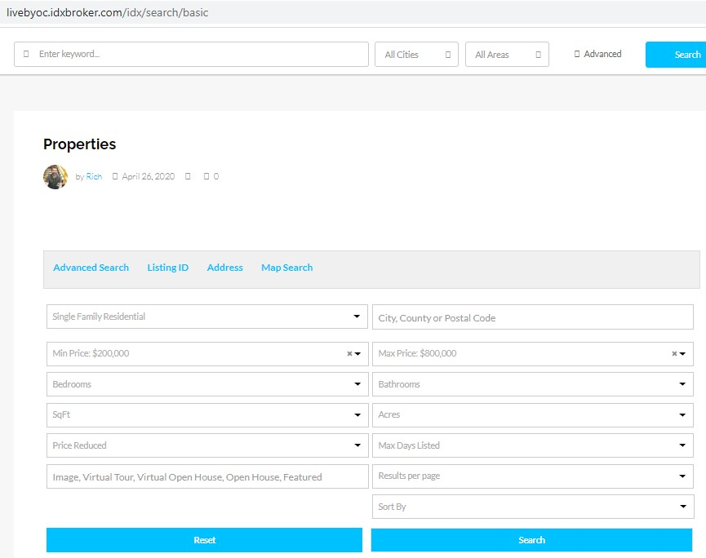

## **Advanced Search**

The buyer can then give the complete specification of a property with its features, description through this advance search options. They will have the best filtered results.

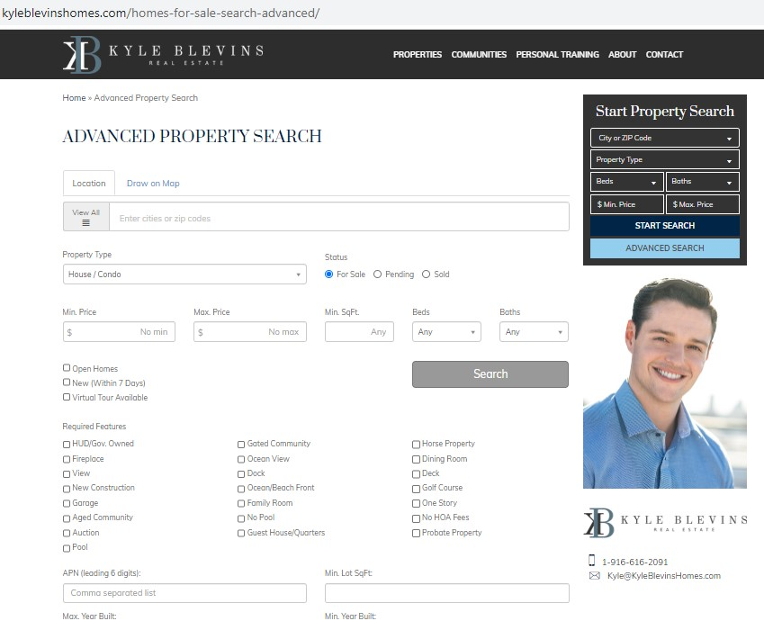

## **Map Search**

Potential homebuyers can search for locations near them powered by the API, and Open Listings sorts them with custom icons and clustering to keep the map view clean and easy to use. It’s a simple polygon map.



# 3.6 CRM integration from IDX provider

CRM is the process of collecting relevant information on clients over time, storing that information in a safe, organized manner, and then searching and filtering that information for insight into your business in order to drive more relevant and personalized communications.

**CRM versus CRM System**

|  |  |
| --- | --- |
| **CRM** | **CRM SYSTEM** |
| CRM is a process and an approach to doing business that develops stronger client relationships. | A CRM System on the other hand, is typically a software tool that enables and automates the process of client relation ship management. |

#### CRM Integration

IDX Broker can send new results in your Top Producer account automatically. to require advantage of this feature, you'll got to follow a couple of simple steps:

Log in to your IDX Broker instrument panel .

Click Leads within the main menu, and Lead Registration within the submenu.

Switch from simple to Advanced mode, then click the CRM Integration tab.

In the Top Producer section, select Yes for "Push All New results in Top Producer 8i" and click on Save Changes at rock bottom of the screen.

Copy your Username and Password into a document .

You will got to add these values within the Top Producer Lead Provider setup. Login to your Top Producer 8i account.

Click on your account name and attend Settings. Click on Contacts from the Settings menu, next click on My Leads.

Click on Contacts from the Settings menu, next click on My Leads.

Click the Add Lead Provider button to save lots of .IDX Broker should display as a lead provider and standing should be "Active."

All new IDX Broker leads will now be pushed to your Top Producer Account!

**CRM Features in Websites:**

CRM tracks your prospect’s activity from the initial search to the closing of the deal. Monitor your current leads, touchpoints, emails, phone calls, contact notes, and clients’ search histories with efficiency. Refindly organizes your data in chronological order, increasing accessibility with a simplified approach to customer relationship management. Strengthen your business and stay connected from any computer or mobile device. Devote **some time** to prospective clients **and permit** REfindly to arm you with the knowledge and insight essential to closing every deal.

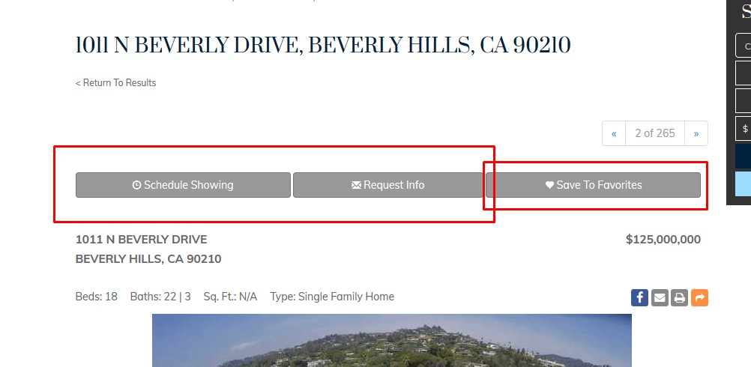

The below image is for taking leads or information from a customer. By this form agent or broker can collect information of a client to sell a house.

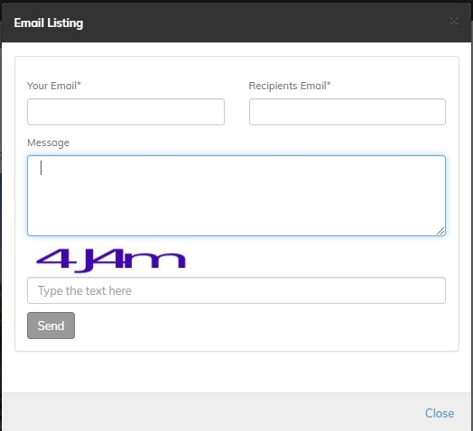 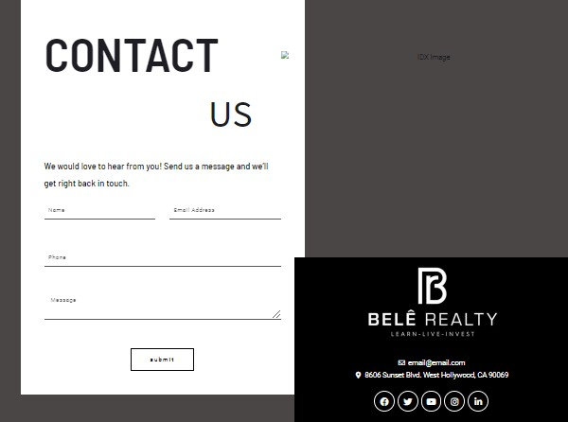

Chapter 4

## Instructive Lesson

### Project -1: <http://kyleblevinshomes.com/>

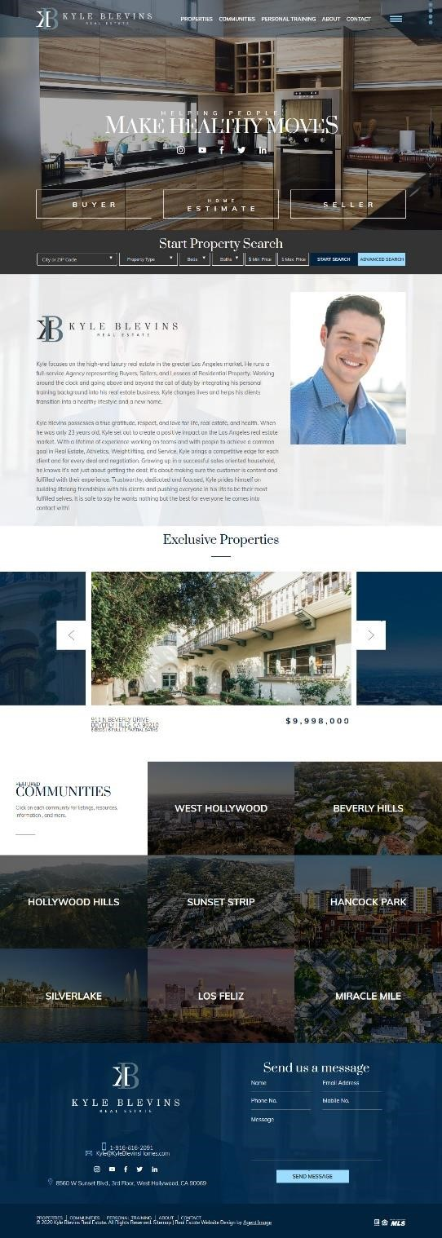

*Figure4.1: HomePage*

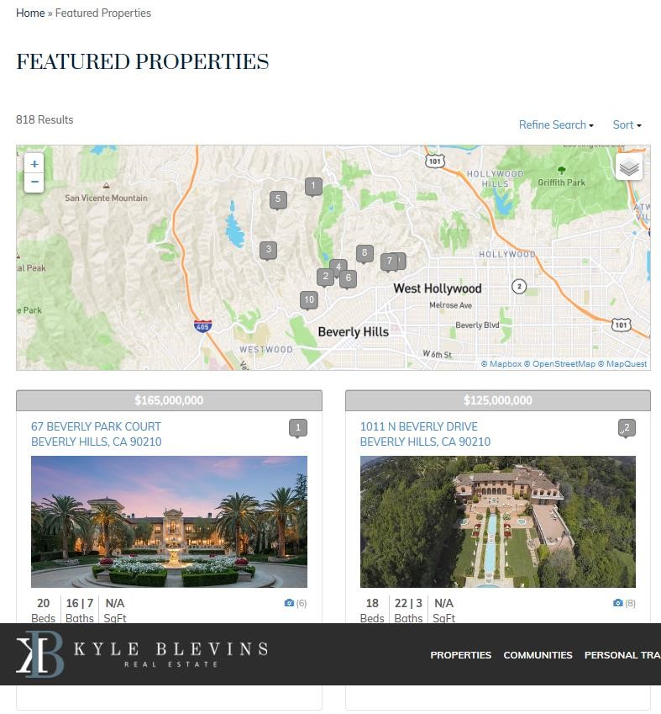

*Figure 4.2: Featured Property*

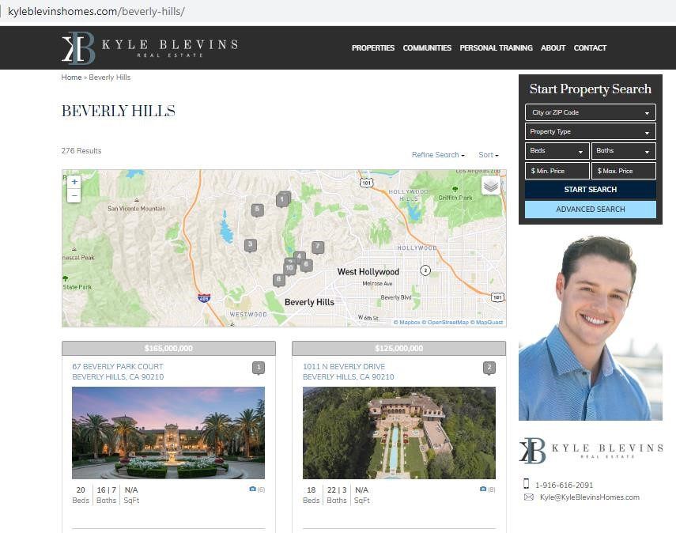

*Figure 4.3: Communities*

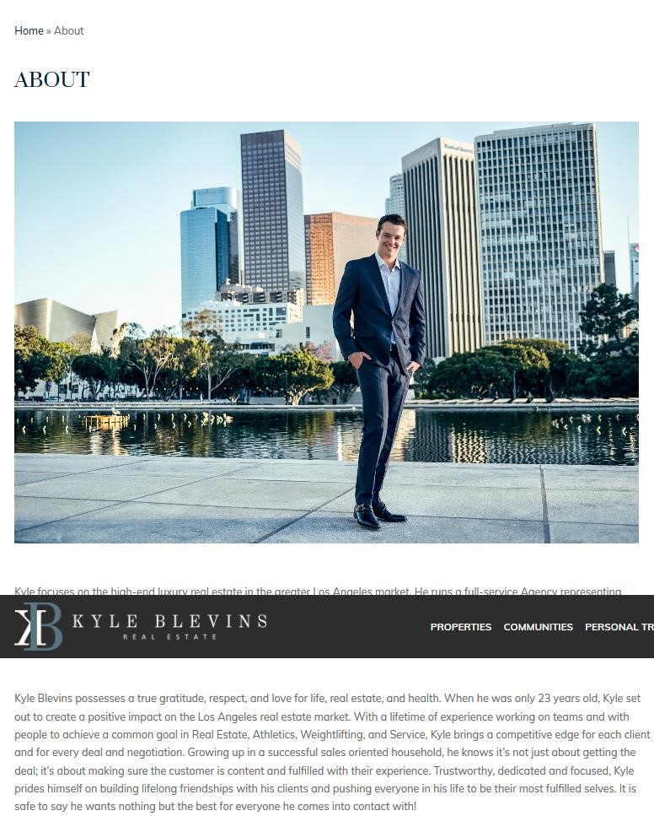  *Figure 4.4: About Page*



*Figure 4.5: Contact Page*

### Project -2: <http://belerealty.com/>

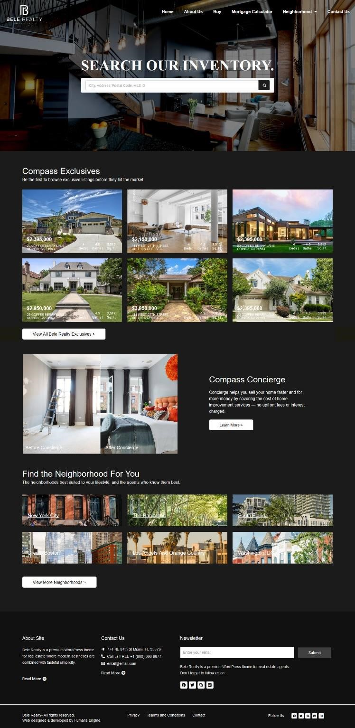

*Figure 4.5: Homepage*

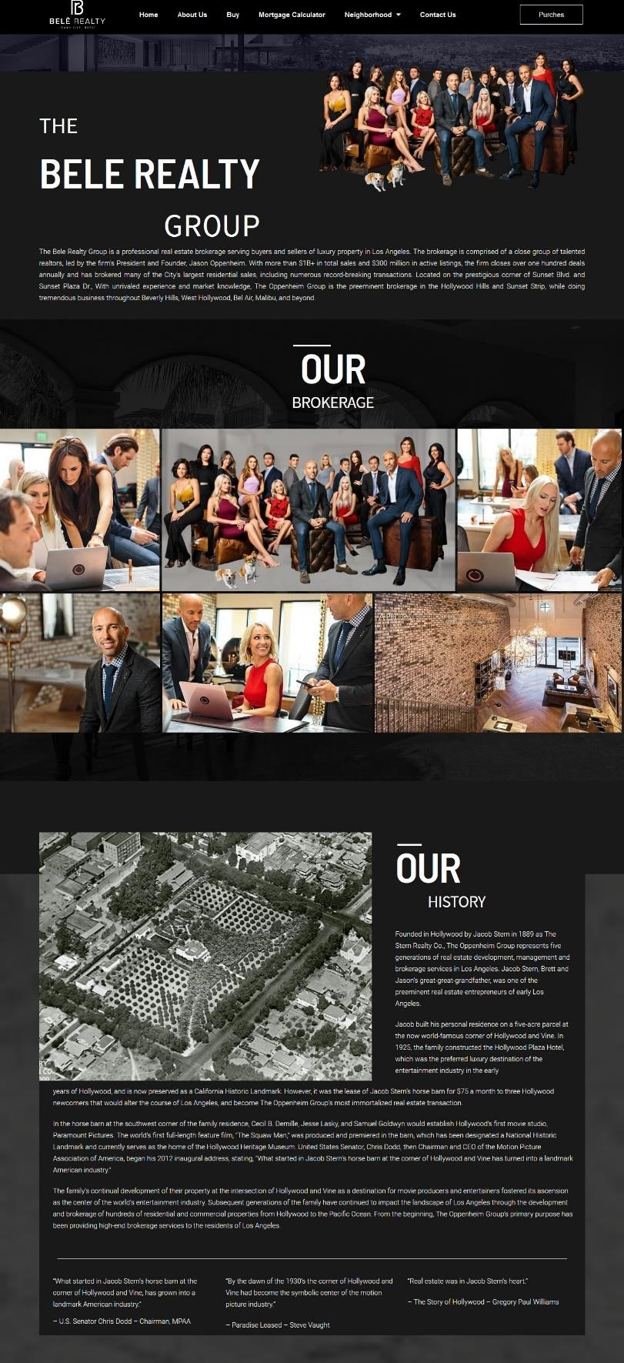

*Figure 4.6: About Page*

*Fi*

*gure 4.*

*7*

*:*

*Buy Page*

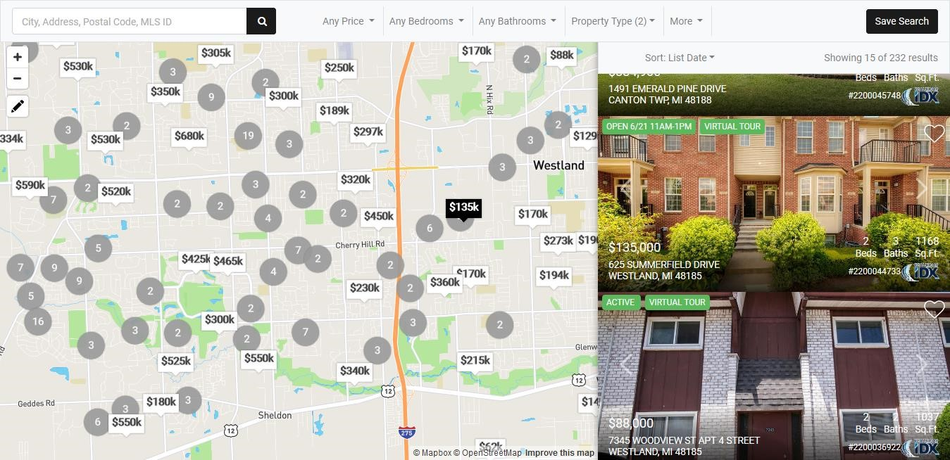

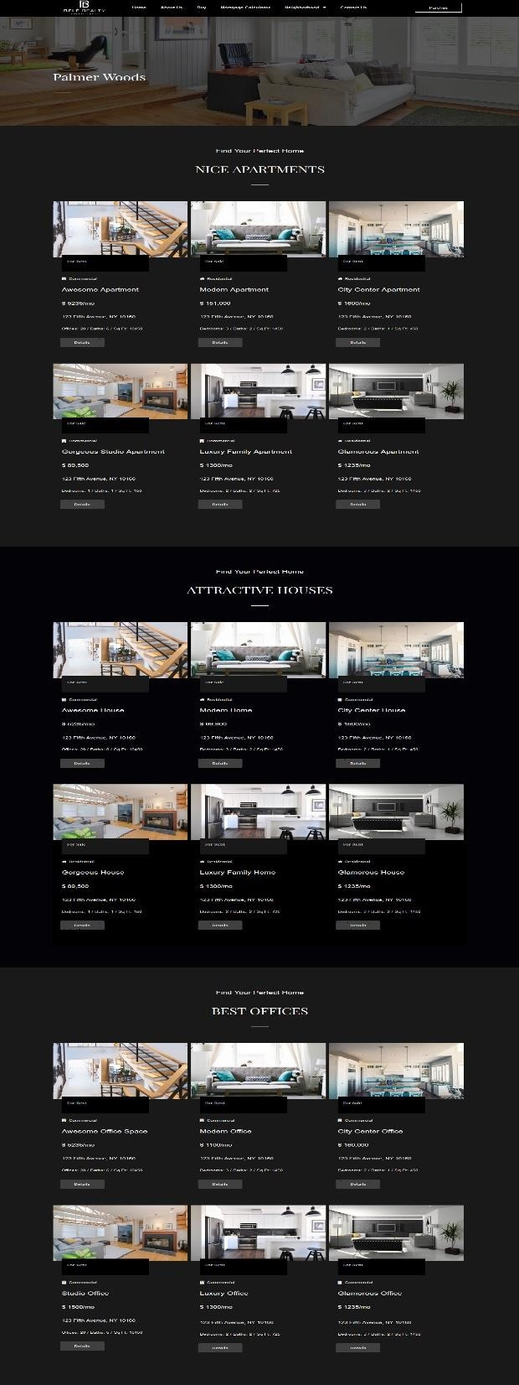

*Figure 4.8: Neighborhood*

*Figure 4*

*9*

*:*

*Contact Page*

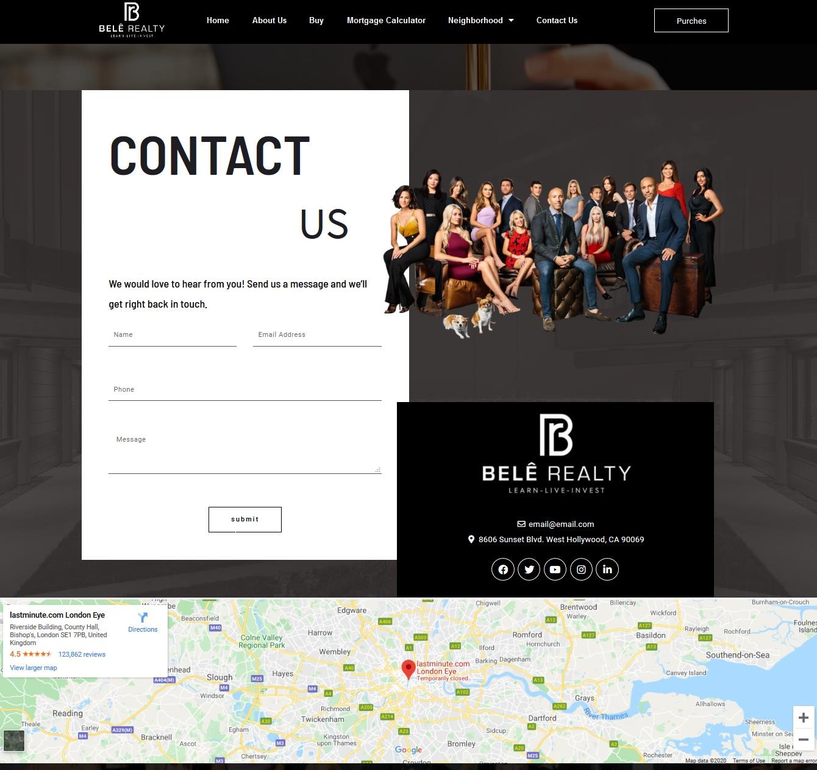

### Project 3: <https://livebyoc.com/>

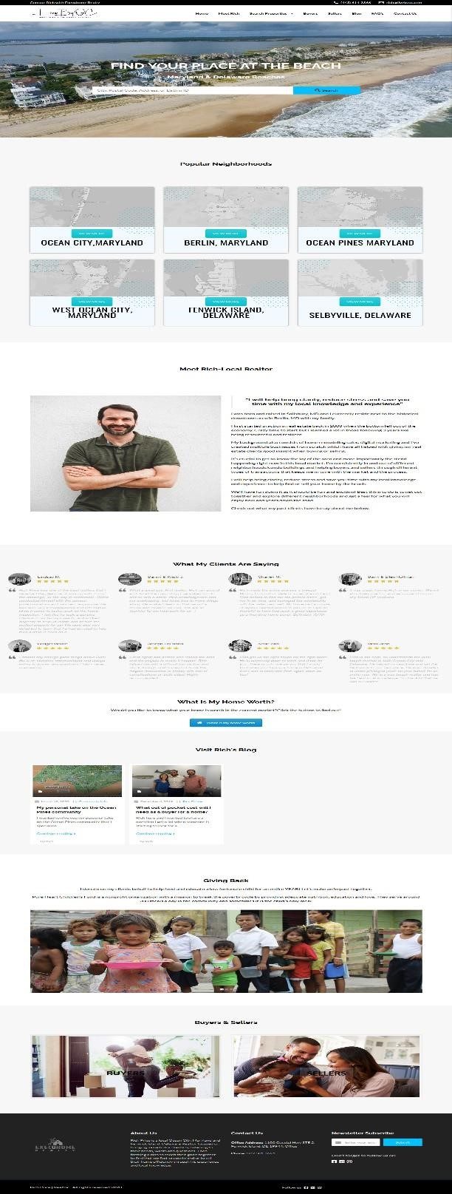

*Figure 4.10: HomePage*

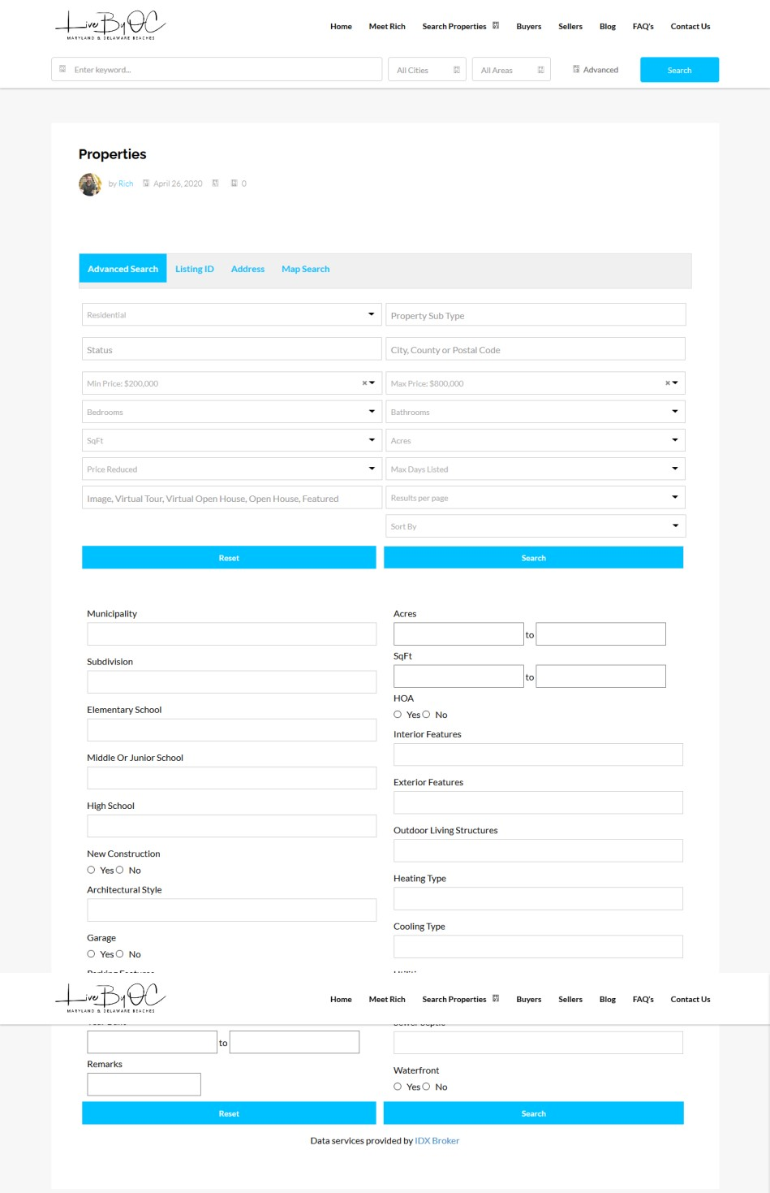

*Figure 4.11: Advanced Search*

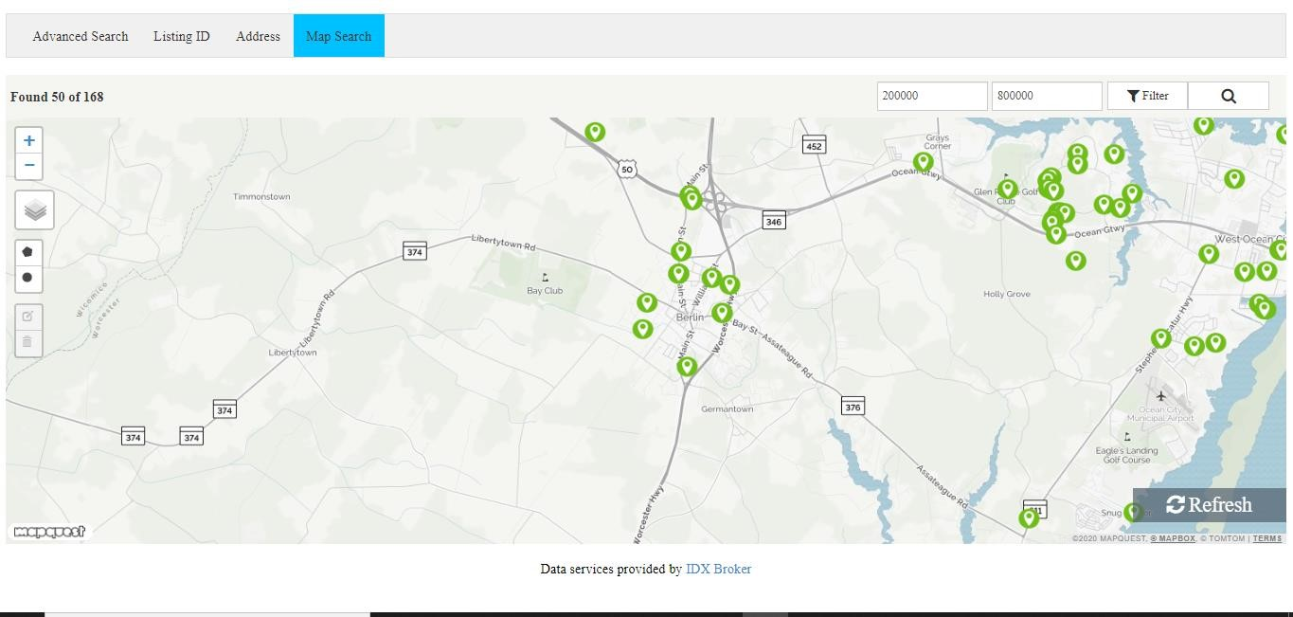

*Figure 4.12:MapSearch*

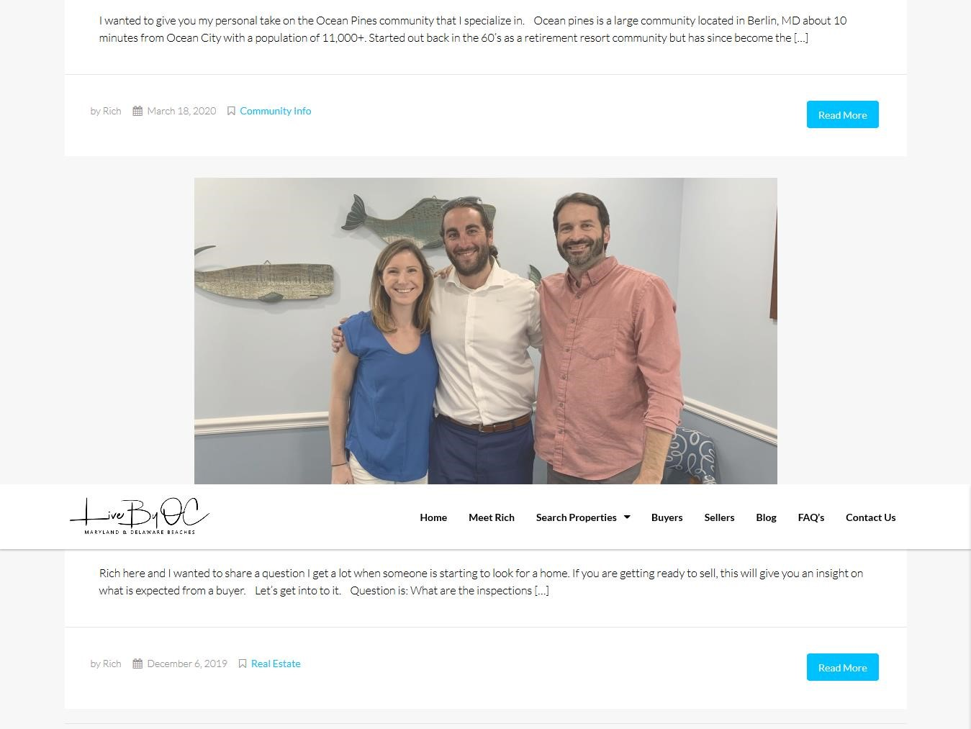

*Figure 4.13: Blog Page*

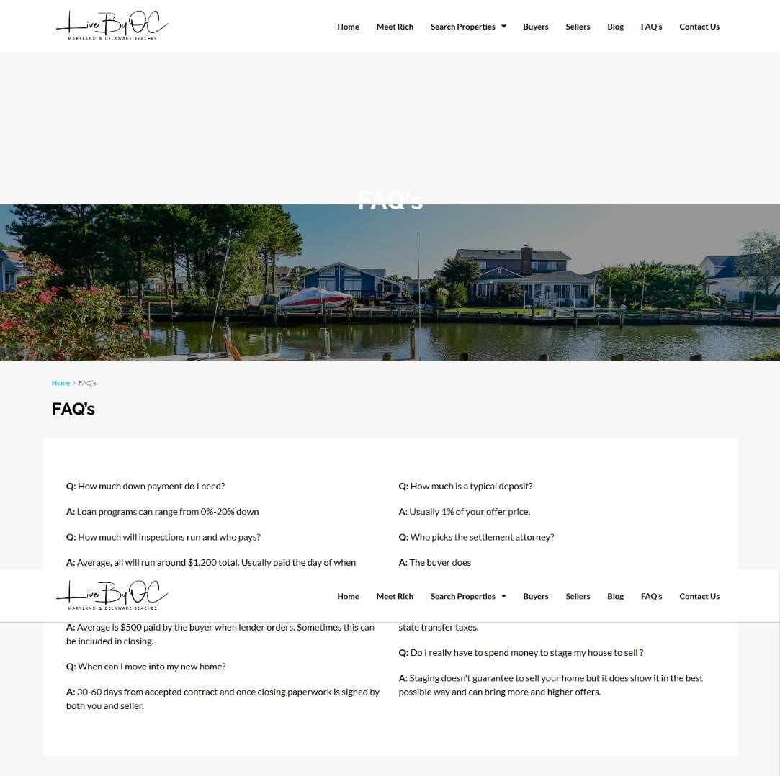

*Figure 4.14:FAQ*

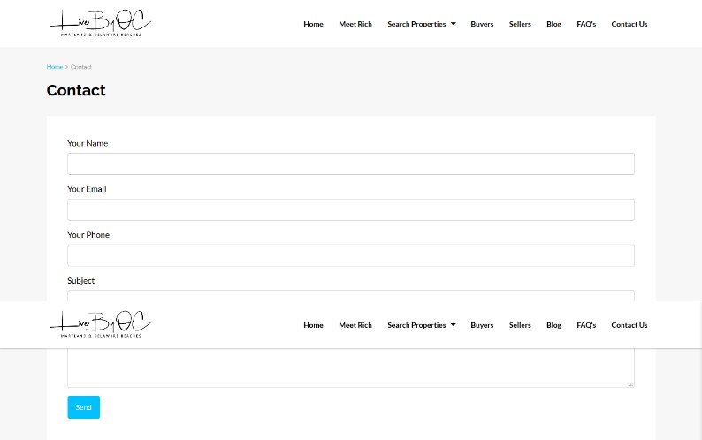

*Figure 4.15: ContactPage*

#### 4.1 Learned from the Institute

We had worked as an intern at MadenetIT for 3 months. It’s a different expectation of our life to get real-life experience in the corporate world. During our work, we have to do a lot of things that helped us learn different things.

1. Dependability: Most of the companies do not want to involve their interns in their core or realtime projects. They think it will be very risky and time consuming for them to involve interns because after three or six months interns will go eventually. But this did not happen in our case. Our co-supervisor involved us in one of the major project. After did this project successfully we were assigned to another real-time project, which was also appreciated. All these shreds of evidence are clear enough to bear the testimony of my dependability

1. **Learned Time management:** Time management is one of the most important things in the corporate world. During our internship period sometimes we need to finish the task in a very short time. We have also learned how to work under pressure without making errors.

1. **Building relationship with professionals**: This internship program has got us the opportunity to meet and work with professionals and build healthy relationships, thus increasing our professional networking.

1. **Communication skill:** During the internship program, the most valuable thing we learned is communication skills. This bank emphasizes communication; they are both facing and experiencing local as well as virtual communication.

1. **Initiative:** As we were assigned to develop websites, sometimes the layout or design we wanted to create we could not do that. Then we tried ourselves to do it with full of our efforts. Even we took five to six days to do one-page design. But we did not lose hope. So we think this will help us in the end.

#### 4.2 Implication to University’s Internship Program

This internship is an integral part of our CSE program. SEU has given us this opportunity to have a practical job experience before getting into our corporate life as a full-time employee.

From university program we have learned:

1. How to utilize theoretical lessons to practical life.

1. How to match educational knowledge in professional life.

1. How to communicate with corporate people.

1. How to present our work activities in the report.

So, definitely this internship program will help us a lot in job sectors.

#### 4.3 Effects on personal skills

The effects of this internship opportunity were so great for us. It developed our

professional skills as well as personal skills to adjust to a new environment.

We are really grateful for giving this opportunity before becoming a full-time employee of any organization.

Chapter Five

Limitations

One of the biggest limitations of **MadenetIT** is having a very poor server.

Their internet network service is very slow.

Throughout our internship, we faced a problem regarding this. Some times the internet connection failed and we had to wait till the connection came. Apparently, Internship is a limited program.

So as per this policy, the company knows its binds to do. But we had to say, we have got enough as an Intern. But there were some limitations too. We didn’t have the authorization to join like, attending official targeted product meetings, giving a new idea, changing method of solution, etc. But above all, as a fresher, We need to learn best, so We have not complained or regret.

Chapter Six Conclusion

It was a great opportunity for us to complete our intern in **Madenet IT**. It is one of the leading companies in Bangladesh.

We spent around three months and experienced a lot of things during our internship program in a friendly environment which encourage us to learn more.

At **Madenet IT**, we observed the working environment and their official activities. Within this short period of time, we tried our best level to acquire knowledge about the work.

The theories and labs that we have learned in the university also helped us a lot to work in **Madenet IT**.

We hope this experience will extend our knowledge and will help us to build a bright future in the field of job.

## Chapter 7 References

<https://madenetit.com/>

[http://kyleblevinshomes.com/](http://kyleblevinshomes.com/f)

<http://belerealty.com/>

<https://livebyoc.com/>

<https://www.hostgator.com/help/>

<http://webaartz.com/>

<https://www.tutorialspoint.com/wordpress/>

<https://support.idxbroker.com/>